Swaziland

## GNI per capita and development level

The data set shows the GNI per capita and development level of the country each year.

## # A tibble: 19 x 5  
## country iso3c date GNIperCapita devCategory  
## <chr> <chr> <dbl> <dbl> <chr>   
## 1 Swaziland SWZ 1996 629. <NA>   
## 2 Swaziland SWZ 1998 675. <NA>   
## 3 Swaziland SWZ 2000 1991. <NA>   
## 4 Swaziland SWZ 2002 1991. <NA>   
## 5 Swaziland SWZ 2003 1565. <NA>   
## 6 Swaziland SWZ 2004 629. <NA>   
## 7 Swaziland SWZ 2005 629. <NA>   
## 8 Swaziland SWZ 2006 629. <NA>   
## 9 Swaziland SWZ 2007 4913. <NA>   
## 10 Swaziland SWZ 2008 629. <NA>   
## 11 Swaziland SWZ 2009 606. <NA>   
## 12 Swaziland SWZ 2010 606. <NA>   
## 13 Swaziland SWZ 2011 606. <NA>   
## 14 Swaziland SWZ 2012 606. <NA>   
## 15 Swaziland SWZ 2013 606. <NA>   
## 16 Swaziland SWZ 2014 606. <NA>   
## 17 Swaziland SWZ 2015 606. <NA>   
## 18 Swaziland SWZ 2016 606. <NA>   
## 19 Swaziland SWZ 2017 649. <NA>

## GDP growth and economic growth classification

The data set shows the GDP growth and the ecomic growth classification of the country each year.

## # A tibble: 19 x 5  
## country iso3c date GDPannualGrowthRate GDPgrowthCategory4  
## <chr> <chr> <dbl> <dbl> <fct>   
## 1 Swaziland SWZ 1996 4.93 moderate growth   
## 2 Swaziland SWZ 1998 4.80 moderate growth   
## 3 Swaziland SWZ 2000 6.37 fast growth   
## 4 Swaziland SWZ 2002 6.37 fast growth   
## 5 Swaziland SWZ 2003 6.93 fast growth   
## 6 Swaziland SWZ 2004 1.45 slow growth   
## 7 Swaziland SWZ 2005 1.45 slow growth   
## 8 Swaziland SWZ 2006 1.45 slow growth   
## 9 Swaziland SWZ 2007 7.73 fast growth   
## 10 Swaziland SWZ 2008 1.45 slow growth   
## 11 Swaziland SWZ 2009 1.45 slow growth   
## 12 Swaziland SWZ 2010 1.45 slow growth   
## 13 Swaziland SWZ 2011 1.45 slow growth   
## 14 Swaziland SWZ 2012 1.45 slow growth   
## 15 Swaziland SWZ 2013 1.45 slow growth   
## 16 Swaziland SWZ 2014 1.45 slow growth   
## 17 Swaziland SWZ 2015 1.45 slow growth   
## 18 Swaziland SWZ 2016 1.45 slow growth   
## 19 Swaziland SWZ 2017 1.45 slow growth

## Development trend

The plot shows the development trend of the country.

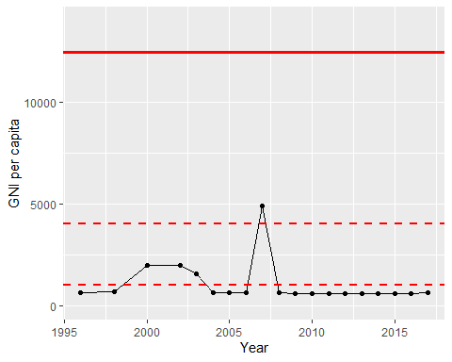

GNI Per Capita Trend